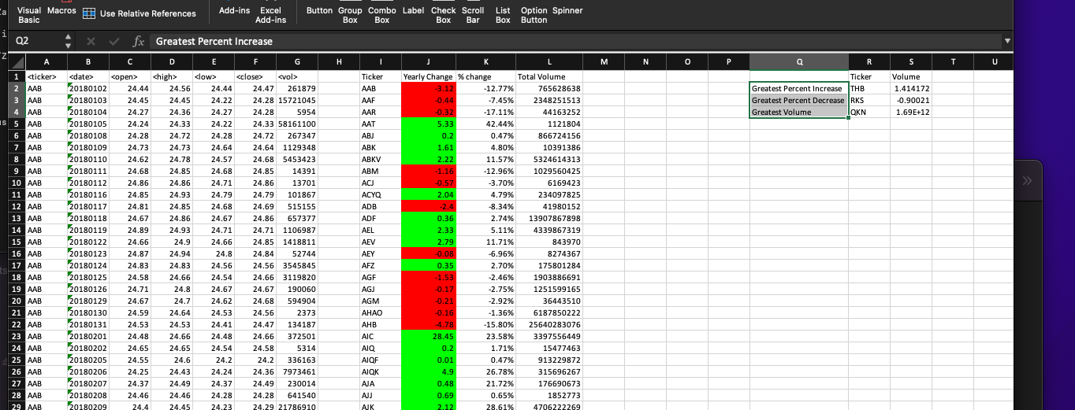
For 2018 I have organized stocks through VBA scripting by ticker, volume, Yearly change and Percent change. I have also displayed the stocks with the greatest percent increase/decrease and greatest volume

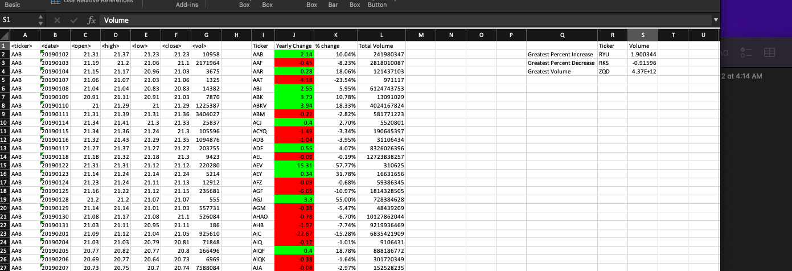
For 2019 I have organized stocks through VBA scripting by ticker, volume, Yearly change and Percent change. I have also displayed the stocks with the greatest percent increase/decrease and greatest volume

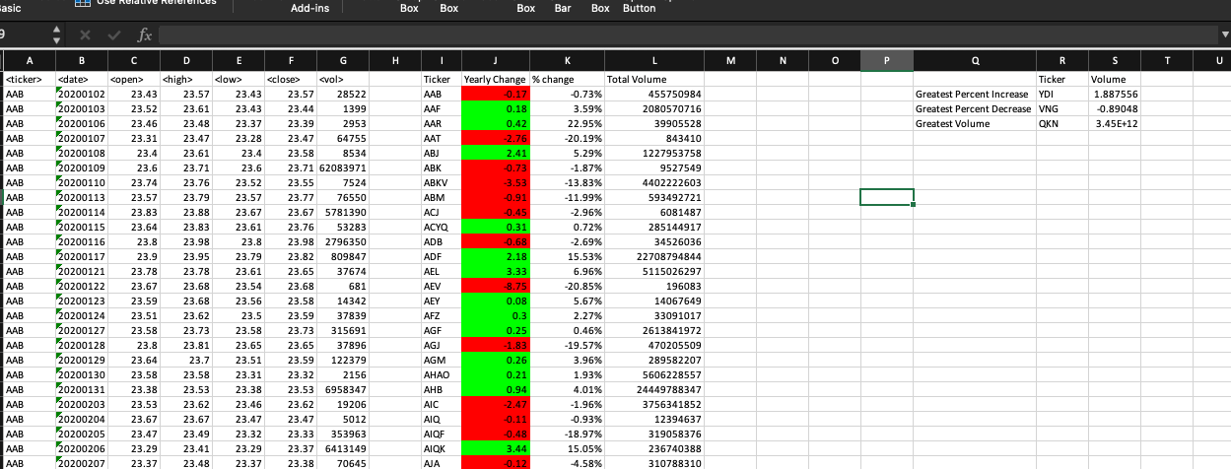
For 2019 I have organized stocks through VBA scripting by ticker, volume, Yearly change and Percent change. I have also displayed the stocks with the greatest percent increase/decrease and greatest volume

